Milestone 9

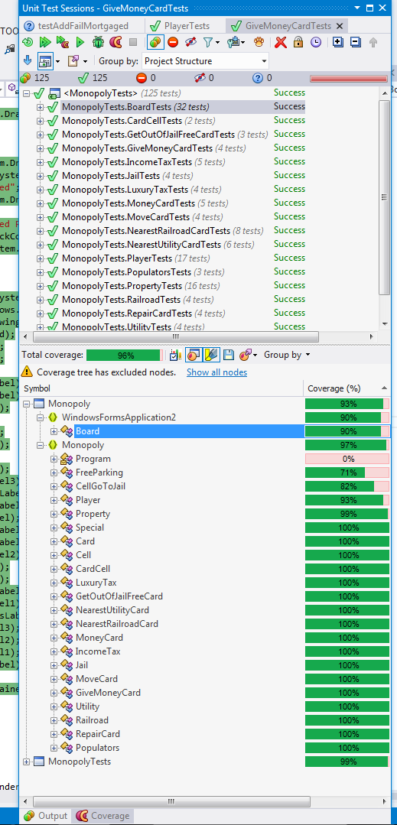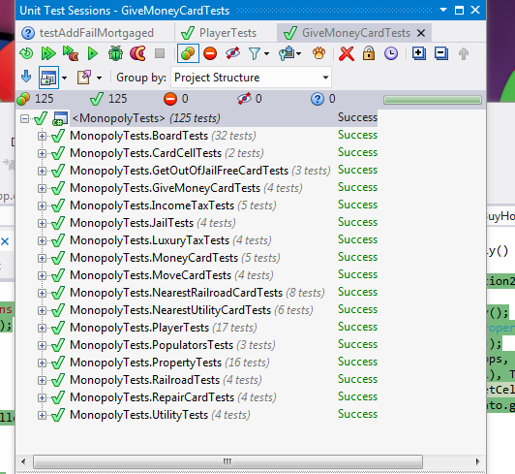

David Gartzke, Brodie Lockard, Francis Meng

**Progress this week**

Internationalized the board as well as associated windows, start and how-to-play menu, and multiplayer support.

**User Scenario for next Milestone**

Polishing up everything and abstract functions within in Board class to separate GUI from testable code.

**Code Coverage**

93%, specific data to the right.

**Lines per team member**

David ~ 80

Brodie ~ 150

Francis ~ 150

**UML diagram**

(next page)

**Metrics**

(attached in excel sheet)

